Forms and Tables Assignment

Que 1: Create a table referring to the image.

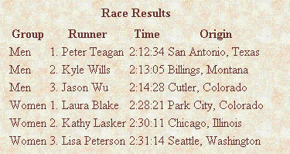

**Code:**

<!doctype html>

<html lang="en">

<head>

<meta charset="UTF-8">

<meta name="viewport"

content="width=device-width, user-scalable=no, initial-scale=1.0, maximum-scale=1.0, minimum-scale=1.0">

<meta http-equiv="X-UA-Compatible" content="ie=edge">

<title>Document</title>

<style>

body{

background: url("assets/bgimage.jpg") no-repeat;

}

</style>

</head>

<body>

<table background="assets/bgimage.jpg" style="color:red;" cellspacing="10px">

<tr>

<th>Group</th>

<th>Runner</th>

<th>Time</th>

<th>Origin</th>

</tr>

<tr>

<td>Men</td>

<td>1.Kamal Pandey</td>

<td>2:12:34</td>

<td>Dwarka, New Delhi</td>

</tr>

<tr>

<td>Men</td>

<td>1.Kamal Pandey</td>

<td>2:12:34</td>

<td>Dwarka, New Delhi</td>

</tr>

<tr>

<td>Men</td>

<td>1.Kamal Pandey</td>

<td>2:12:34</td>

<td>Dwarka, New Delhi</td>

</tr>

<tr>

<td>Men</td>

<td>1.Kamal Pandey</td>

<td>2:12:34</td>

<td>Dwarka, New Delhi</td>

</tr>

<tr>

<td>Men</td>

<td>1.Kamal Pandey</td>

<td>2:12:34</td>

<td>Dwarka, New Delhi</td>

</tr>

<tr>

<td>Men</td>

<td>1.Kamal Pandey</td>

<td>2:12:34</td>

<td>Dwarka, New Delhi</td>

</tr>

</table>

</body>

</html>

**Output:**

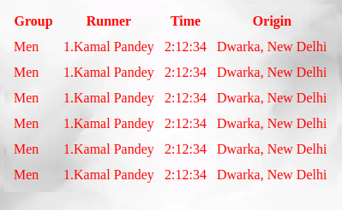

**Que 2:** Create a table referring to the image

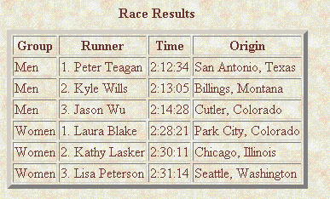

**Code:**

<!doctype html>

<html lang="en">

<head>

<meta charset="UTF-8">

<meta name="viewport"

content="width=device-width, user-scalable=no, initial-scale=1.0, maximum-scale=1.0, minimum-scale=1.0">

<meta http-equiv="X-UA-Compatible" content="ie=edge">

<title>Document</title>

<style>

body{

background: url("assets/bgimage.jpg") no-repeat;

}

</style>

</head>

<body>

<table background="assets/bgimage.jpg" style="color:red;" border="5px">

<caption>Race Results</caption>

<tr>

<th>Group</th>

<th>Runner</th>

<th>Time</th>

<th>Origin</th>

</tr>

<tr>

<td>Men</td>

<td>1.Kamal Pandey</td>

<td>2:12:34</td>

<td>Dwarka, New Delhi</td>

</tr>

<tr>

<td>Men</td>

<td>1.Kamal Pandey</td>

<td>2:12:34</td>

<td>Dwarka, New Delhi</td>

</tr>

<tr>

<td>Men</td>

<td>1.Kamal Pandey</td>

<td>2:12:34</td>

<td>Dwarka, New Delhi</td>

</tr>

<tr>

<td>Men</td>

<td>1.Kamal Pandey</td>

<td>2:12:34</td>

<td>Dwarka, New Delhi</td>

</tr>

<tr>

<td>Men</td>

<td>1.Kamal Pandey</td>

<td>2:12:34</td>

<td>Dwarka, New Delhi</td>

</tr>

<tr>

<td>Men</td>

<td>1.Kamal Pandey</td>

<td>2:12:34</td>

<td>Dwarka, New Delhi</td>

</tr>

</table>

</body>

</html>

**Output:**

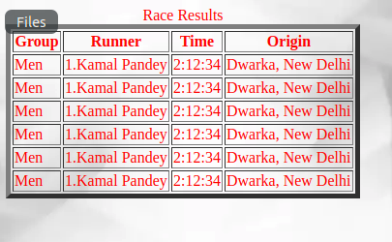

**Que 3:** Create a table and set the width to 500px . Also, keep cellspacing and cellpadding 0

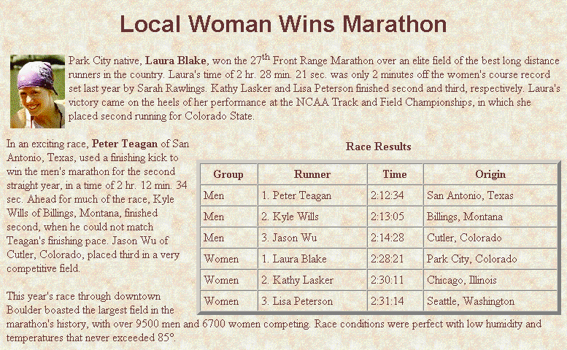

**Code:**

<!doctype html>

<html lang="en">

<head>

<meta charset="UTF-8">

<meta name="viewport"

content="width=device-width, user-scalable=no, initial-scale=1.0, maximum-scale=1.0, minimum-scale=1.0">

<meta http-equiv="X-UA-Compatible" content="ie=edge">

<title>Document</title>

<style>

body{

background: url("assets/bgimage2.jpeg ");

color: #fff;

}

h1 {

text-align: center;

}

table {

float: right;

width: 600px;

height: 250px;

}

img {

float: left;

margin-right: 20px;

}

</style>

</head>

<body>

<div class="container">

<h1>Local Woman Wins Marathon</h1>

<p><img src="assets/image.jpeg" alt="">Lorem ipsum dolor sit amet, consectetur adipisicing elit. Beatae dignissimos doloremque dolores, error est et fugit in ipsum laborum laudantium molestias mollitia nam nemo nihil nobis possimus sequi vero, vitae.

Lorem ipsum dolor sit amet, consectetur adipisicing elit. Cumque cupiditate nemo praesentium quibusdam sit tempora voluptatem? Eius enim error esse inventore maxime nesciunt nisi praesentium quia quisquam sunt, tempora vitae?

Lorem ipsum dolor sit amet, consectetur adipisicing elit. Distinctio ea eaque eius id modi, similique! Excepturi perspiciatis recusandae temporibus veritatis. Eum molestiae nemo quam quisquam quod. Corporis impedit laudantium saepe.

Lorem ipsum dolor sit amet, consectetur adipisicing elit. Aspernatur aut blanditiis, dignissimos distinctio, dolorem doloribus eligendi error eum incidunt mollitia neque obcaecati possimus quas qui quidem recusandae repellendus sint vitae?

Lorem ipsum dolor sit amet, consectetur adipisicing elit. Cumque dolorem esse minima quidem saepe, temporibus! Ab alias, consectetur culpa deleniti eligendi laboriosam nam nulla pariatur provident quo reprehenderit, sed, voluptates.

Lorem ipsum dolor sit amet, consectetur adipisicing elit. Accusamus amet architecto cumque dolore doloremque, fugit harum illo ipsa itaque maiores nam repellat, sapiente sit tempore unde. Eaque magni nihil quaerat.

Lorem ipsum dolor sit amet, consectetur adipisicing elit. Beatae dignissimos doloremque dolores, error est et fugit in ipsum laborum laudantium molestias mollitia nam nemo nihil nobis possimus sequi vero, vitae.

Lorem ipsum dolor sit amet, consectetur adipisicing elit. Cumque cupiditate nemo praesentium quibusdam sit tempora voluptatem? Eius enim error esse inventore maxime nesciunt nisi praesentium quia quisquam sunt, tempora vitae?

Lorem ipsum dolor sit amet, consectetur adipisicing elit. Distinctio ea eaque eius id modi, similique! Excepturi perspiciatis recusandae temporibus veritatis. Eum molestiae nemo quam quisquam quod. Corporis impedit laudantium saepe.

Lorem ipsum dolor sit amet, consectetur adipisicing elit. Aspernatur aut blanditiis, dignissimos distinctio, dolorem doloribus eligendi error eum incidunt mollitia neque obcaecati possimus quas qui quidem recusandae repellendus sint vitae?

Lorem ipsum dolor sit amet, consectetur adipisicing elit. Cumque dolorem esse minima quidem saepe, temporibus! Ab alias, consectetur culpa deleniti eligendi laboriosam nam nulla pariatur provident quo reprehenderit, sed, voluptates.

Lorem ipsum dolor sit amet, consectetur adipisicing elit. Accusamus amet architecto cumque dolore doloremque, fugit harum illo ipsa itaque maiores nam repellat, sapiente sit tempore unde. Eaque magni nihil quaerat.

Lorem ipsum dolor sit amet, consectetur adipisicing elit. Beatae dignissimos doloremque dolores, error est et fugit in ipsum laborum laudantium molestias mollitia nam nemo nihil nobis possimus sequi vero, vitae.

Lorem ipsum dolor sit amet, consectetur adipisicing elit. Cumque cupiditate nemo praesentium quibusdam sit tempora voluptatem? Eius enim error esse inventore maxime nesciunt nisi praesentium quia quisquam sunt, tempora vitae?

Lorem ipsum dolor sit amet, consectetur adipisicing elit. Distinctio ea eaque eius id modi, similique! Excepturi perspiciatis recusandae temporibus veritatis. Eum molestiae nemo quam quisquam quod. Corporis impedit laudantium saepe.

Lorem ipsum dolor sit amet, consectetur adipisicing elit. Aspernatur aut blanditiis, dignissimos distinctio, dolorem doloribus eligendi error eum incidunt mollitia neque obcaecati possimus quas qui quidem recusandae repellendus sint vitae?

Lorem ipsum dolor sit amet, consectetur adipisicing elit. Cumque dolorem esse minima quidem saepe, temporibus! Ab alias, consectetur culpa deleniti eligendi laboriosam nam nulla pariatur provident quo reprehenderit, sed, voluptates.

Lorem ipsum dolor sit amet, consectetur adipisicing elit. Accusamus amet architecto cumque dolore doloremque, fugit harum illo ipsa itaque maiores nam repellat, sapiente sit tempore unde. Eaque magni nihil quaerat.

Lorem ipsum dolor sit amet, consectetur adipisicing elit. Beatae dignissimos doloremque dolores, error est et fugit in ipsum laborum laudantium molestias mollitia nam nemo nihil nobis possimus sequi vero, vitae.

<table background="assets/bgimage.jpg" style="color:red;" border="5px">

<caption>Race Results</caption>

<tr>

<th>Group</th>

<th>Runner</th>

<th>Time</th>

<th>Origin</th>

</tr>

<tr>

<td>Men</td>

<td>1.Kamal Pandey</td>

<td>2:12:34</td>

<td>Dwarka, New Delhi</td>

</tr>

<tr>

<td>Men</td>

<td>1.Kamal Pandey</td>

<td>2:12:34</td>

<td>Dwarka, New Delhi</td>

</tr>

<tr>

<td>Men</td>

<td>1.Kamal Pandey</td>

<td>2:12:34</td>

<td>Dwarka, New Delhi</td>

</tr>

<tr>

<td>Men</td>

<td>1.Kamal Pandey</td>

<td>2:12:34</td>

<td>Dwarka, New Delhi</td>

</tr>

<tr>

<td>Men</td>

<td>1.Kamal Pandey</td>

<td>2:12:34</td>

<td>Dwarka, New Delhi</td>

</tr>

<tr>

<td>Men</td>

<td>1.Kamal Pandey</td>

<td>2:12:34</td>

<td>Dwarka, New Delhi</td>

</tr>

</table>

Lorem ipsum dolor sit amet, consectetur adipisicing elit. Cumque cupiditate nemo praesentium quibusdam sit tempora voluptatem? Eius enim error esse inventore maxime nesciunt nisi praesentium quia quisquam sunt, tempora vitae?

Lorem ipsum dolor sit amet, consectetur adipisicing elit. Distinctio ea eaque eius id modi, similique! Excepturi perspiciatis recusandae temporibus veritatis. Eum molestiae nemo quam quisquam quod. Corporis impedit laudantium saepe.

Lorem ipsum dolor sit amet, consectetur adipisicing elit. Aspernatur aut blanditiis, dignissimos distinctio, dolorem doloribus eligendi error eum incidunt mollitia neque obcaecati possimus quas qui quidem recusandae repellendus sint vitae?

Lorem ipsum dolor sit amet, consectetur adipisicing elit. Cumque dolorem esse minima quidem saepe, temporibus! Ab alias, consectetur culpa deleniti eligendi laboriosam nam nulla pariatur provident quo reprehenderit, sed, voluptates.

Lorem ipsum dolor sit amet, consectetur adipisicing elit. Accusamus amet architecto cumque dolore doloremque, fugit harum illo ipsa itaque maiores nam repellat, sapiente sit tempore unde. Eaque magni nihil quaerat.

Lorem ipsum dolor sit amet, consectetur adipisicing elit. Beatae dignissimos doloremque dolores, error est et fugit in ipsum laborum laudantium molestias mollitia nam nemo nihil nobis possimus sequi vero, vitae.

Lorem ipsum dolor sit amet, consectetur adipisicing elit. Cumque cupiditate nemo praesentium quibusdam sit tempora voluptatem? Eius enim error esse inventore maxime nesciunt nisi praesentium quia quisquam sunt, tempora vitae?

Lorem ipsum dolor sit amet, consectetur adipisicing elit. Distinctio ea eaque eius id modi, similique! Excepturi perspiciatis recusandae temporibus veritatis. Eum molestiae nemo quam quisquam quod. Corporis impedit laudantium saepe.

Lorem ipsum dolor sit amet, consectetur adipisicing elit. Aspernatur aut blanditiis, dignissimos distinctio, dolorem doloribus eligendi error eum incidunt mollitia neque obcaecati possimus quas qui quidem recusandae repellendus sint vitae?

Lorem ipsum dolor sit amet, consectetur adipisicing elit. Cumque dolorem esse minima quidem saepe, temporibus! Ab alias, consectetur culpa deleniti eligendi laboriosam nam nulla pariatur provident quo reprehenderit, sed, voluptates.

Lorem ipsum dolor sit amet, consectetur adipisicing elit. Accusamus amet architecto cumque dolore doloremque, fugit harum illo ipsa itaque maiores nam repellat, sapiente sit tempore unde. Eaque magni nihil quaerat.

Lorem ipsum dolor sit amet, consectetur adipisicing elit. Beatae dignissimos doloremque dolores, error est et fugit in ipsum laborum laudantium molestias mollitia nam nemo nihil nobis possimus sequi vero, vitae.

Lorem ipsum dolor sit amet, consectetur adipisicing elit. Cumque cupiditate nemo praesentium quibusdam sit tempora voluptatem? Eius enim error esse inventore maxime nesciunt nisi praesentium quia quisquam sunt, tempora vitae?

Lorem ipsum dolor sit amet, consectetur adipisicing elit. Distinctio ea eaque eius id modi, similique! Excepturi perspiciatis recusandae temporibus veritatis. Eum molestiae nemo quam quisquam quod. Corporis impedit laudantium saepe.

Lorem ipsum dolor sit amet, consectetur adipisicing elit. Aspernatur aut blanditiis, dignissimos distinctio, dolorem doloribus eligendi error eum incidunt mollitia neque obcaecati possimus quas qui quidem recusandae repellendus sint vitae?

Lorem ipsum dolor sit amet, consectetur adipisicing elit. Cumque dolorem esse minima quidem saepe, temporibus! Ab alias, consectetur culpa deleniti eligendi laboriosam nam nulla pariatur provident quo reprehenderit, sed, voluptates.

Lorem ipsum dolor sit amet, consectetur adipisicing elit. Accusamus amet architecto cumque dolore doloremque, fugit harum illo ipsa itaque maiores nam repellat, sapiente sit tempore unde. Eaque magni nihil quaerat.</p>

</div>

</body>

</html>

**Output:**

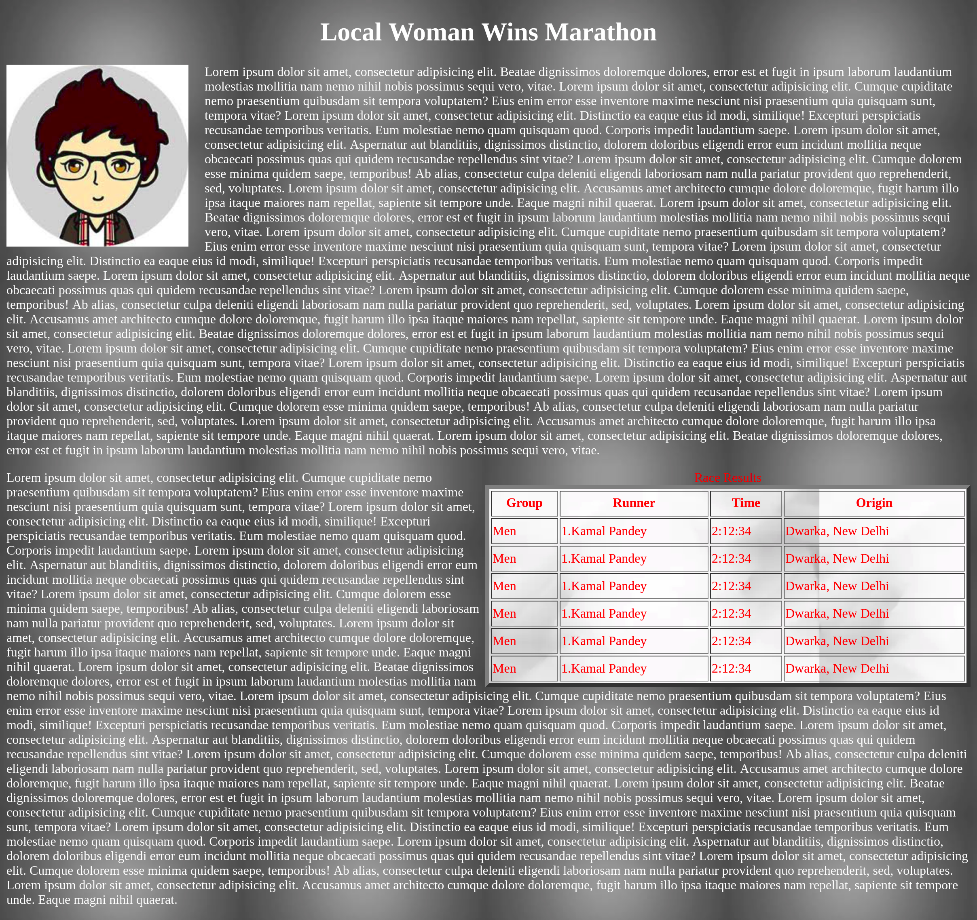

**Que 4:** Create a table referring to the image.

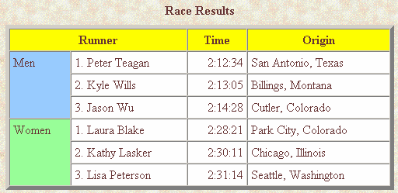

**Code:**

<!doctype html>

<html lang="en">

<head>

<meta charset="UTF-8">

<meta name="viewport"

content="width=device-width, user-scalable=no, initial-scale=1.0, maximum-scale=1.0, minimum-scale=1.0">

<meta http-equiv="X-UA-Compatible" content="ie=edge">

<title>Document</title>

<style>

body{

background: url("assets/bgimage.jpg") no-repeat;

}

</style>

</head>

<body>

<table bgcolor="#fff" border="5" cellspacing="0">

<caption>Race Results</caption>

<tr bgcolor="#ffd700 ">

<th colspan="2">Runner</th>

<th>Time</th>

<th>Origin</th>

</tr>

<tr>

<td rowspan="3" bgcolor="#00ced1">Men</td>

<td>1.Kamal Pandey</td>

<td>2:12:34</td>

<td>Dwarka, New Delhi</td>

</tr>

<tr>

<td>1.Kamal Pandey</td>

<td>2:12:34</td>

<td>Dwarka, New Delhi</td>

</tr>

<tr>

<td>1.Kamal Pandey</td>

<td>2:12:34</td>

<td>Dwarka, New Delhi</td>

</tr>

<tr>

<td rowspan="3" bgcolor="#7fffd4">Women</td>

<td>1.Kamal Pandey</td>

<td>2:12:34</td>

<td>Dwarka, New Delhi</td>

</tr>

<tr>

<td>1.Kamal Pandey</td>

<td>2:12:34</td>

<td>Dwarka, New Delhi</td>

</tr>

<tr>

<td>1.Kamal Pandey</td>

<td>2:12:34</td>

<td>Dwarka, New Delhi</td>

</tr>

</table>

</body>

</html>

**Output:**

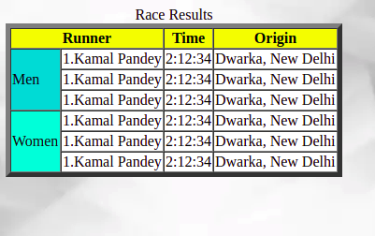

**Que 5:** Create a webpage using nested tables.

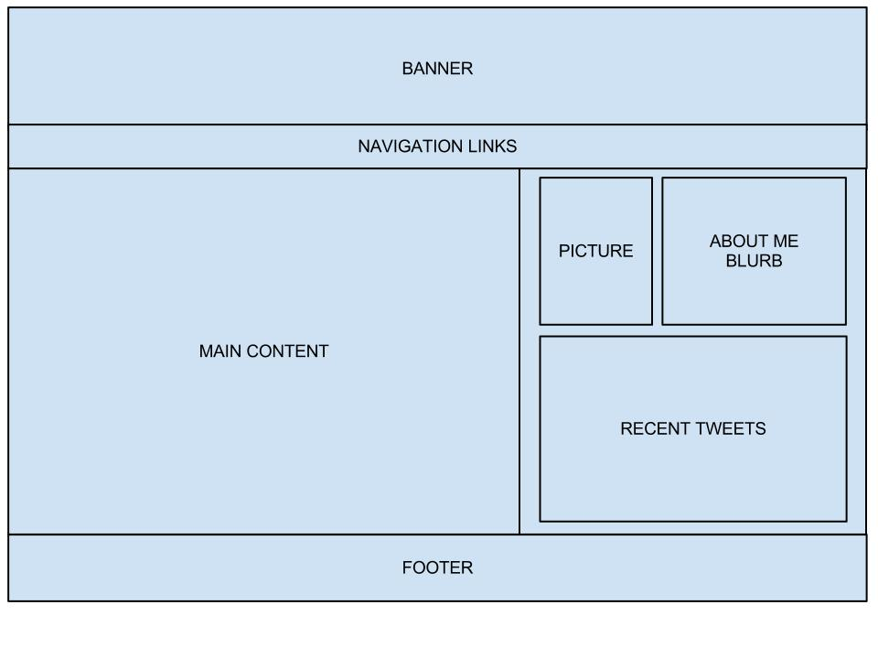

**Code:**

<!doctype html>

<html lang="en">

<head>

<meta charset="UTF-8">

<meta name="viewport"

content="width=device-width, user-scalable=no, initial-scale=1.0, maximum-scale=1.0, minimum-scale=1.0">

<meta http-equiv="X-UA-Compatible" content="ie=edge">

<title>Document</title>

<style>

table{

text-align: center;

}

</style>

</head>

<body>

<table border="1" cellspacing="0" width="100%" height="400px" bgcolor="#7fffd4">

<tr height="100px">

<td colspan="2">Banner</td>

</tr>

<tr height="40px">

<td colspan="2">Navigation Links</td>

</tr>

<tr>

<td>Main Content</td>

<td width="40%">

<table border="1" cellspacing="15" width="100%" height="300px">

<tr>

<td>Picture</td>

<td>About Me</td>

</tr>

<tr>

<td colspan="2">Recent Tweets</td>

</tr>

</table>

</td>

</tr>

<tr height="40px">

<td colspan="2">Footer</td>

</tr>

</table>

</body>

</html>

**Output:**

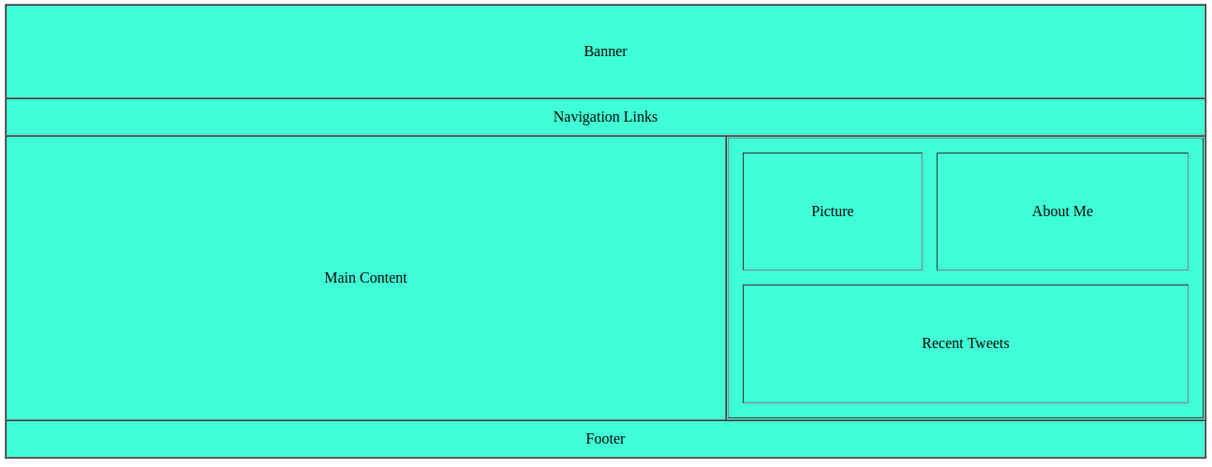

**Que 6:** Create a form like this.

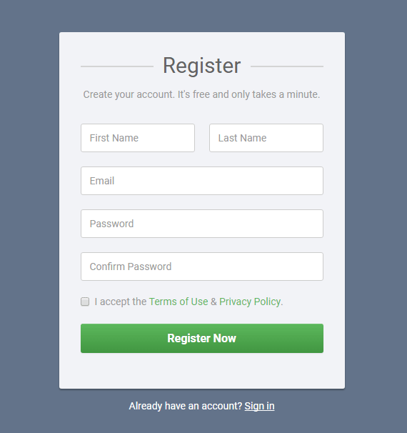

**Code:**

**Index.html**

<!doctype html>

<html lang="en">

<head>

<meta charset="UTF-8">

<meta name="viewport"

content="width=device-width, user-scalable=no, initial-scale=1.0, maximum-scale=1.0, minimum-scale=1.0">

<meta http-equiv="X-UA-Compatible" content="ie=edge">

<title>Document</title>

<link rel="stylesheet" href="css/style.css">

</head>

<body>

<div class="container">

<div class="wrapper">

<div class="hr-row">

</div>

<h1>Register</h1>

<p>Create your account. It's free and only takes a minute.</p>

<form action="#" method="get">

<div class="input-box">

<div class="input-box-half1">

<input type="text" placeholder="First Name" class="firstName" required>

</div>

<div class="input-box-half2">

<input type="text" placeholder="Last Name" class="lastName" required>

</div>

</div>

<div class="input-box">

<input type="email" placeholder="Email" class="email-field" required>

</div>

<div class="input-box">

<input type="password" placeholder="Password" class="password-field" required>

</div>

<div class="input-box">

<input type="password" placeholder="Confirm-Password" class="password-field" required>

</div>

<div class="terms-condition">

<input type="checkbox" class="checkbox-field" required> <label>I accept the <a href="#"> Terms of Use</a> &

<a href="#">Privacy Policy.</a></label>

</div>

<button class="button" type="submit">Register Now</button>

</form>

</div>

</div>

<p class="sign-in">Already <hav></hav>e an account ? <a href="#">Sign in</a></p>

</body>

</html>

**style.css**

/* http://meyerweb.com/eric/tools/css/reset/

v2.0 | 20110126

License: none (public domain)

*/

html, body, div, span, applet, object, iframe,

h1, h2, h3, h4, h5, h6, p, blockquote, pre,

a, abbr, acronym, address, big, cite, code,

del, dfn, em, img, ins, kbd, q, s, samp,

small, strike, strong, sub, sup, tt, var,

b, u, i, center,

dl, dt, dd, ol, ul, li,

fieldset, form, label, legend,

table, caption, tbody, tfoot, thead, tr, th, td,

article, aside, canvas, details, embed,

figure, figcaption, footer, header, hgroup,

menu, nav, output, ruby, section, summary,

time, mark, audio, video {

margin: 0;

padding: 0;

border: 0;

font-size: 100%;

font: inherit;

vertical-align: baseline;

}

/* HTML5 display-role reset for older browsers */

article, aside, details, figcaption, figure,

footer, header, hgroup, menu, nav, section {

display: block;

}

body {

line-height: 1;

}

ol, ul {

list-style: none;

}

blockquote, q {

quotes: none;

}

blockquote:before, blockquote:after,

q:before, q:after {

content: '';

content: none;

}

table {

border-collapse: collapse;

border-spacing: 0;

}

*{

box-sizing: border-box;

}

body{

width: 100%;

font-family: 'Roboto', sans-serif;

background-color: #646e8a;

color: gray;

}

.container{

margin: 50px 400px 0 400px;

background-color: #fff;

border-radius: 5px;

}

.wrapper{

margin: 0px 50px 20px 50px;

position: relative;

}

.hr-row{

border-bottom: 2px solid gray;

padding-top: 40px;

margin-bottom: 20px;

}

.wrapper h1{

position: absolute;

font-weight: 900;

font-family: 'Roboto', sans-serif;

font-size: 30px;

background-color: #fff;

top: 25px;

right: 140px;

}

.wrapper p{

margin-bottom: 25px;

}

.input-box input{

height: 40px;

width: 100%;

margin-bottom: 15px;

padding-left: 15px;

}

.input-box-half1 input{

width: 48%;

float: left;

margin-right: 7px;

}

.input-box-half2 input{

width: 48%;

float: right;

}

.terms-condition label a{

text-decoration: none;

color: #005e00;

}

button{

width: 100%;

margin: 30px 0;

color: #fff;

background-color: #00aa48;

padding: 10px 0;

border-radius: 5px;

cursor: pointer;

font-weight: bold;

font-size: 17px;

border: 1px solid #00aa48;

}

.sign-in{

color: #fff;

text-align: center;

}

.sign-in a{

color: #fff;

}

**Output:**

